**Substitution (0x6C)**

**Documentation Issues**

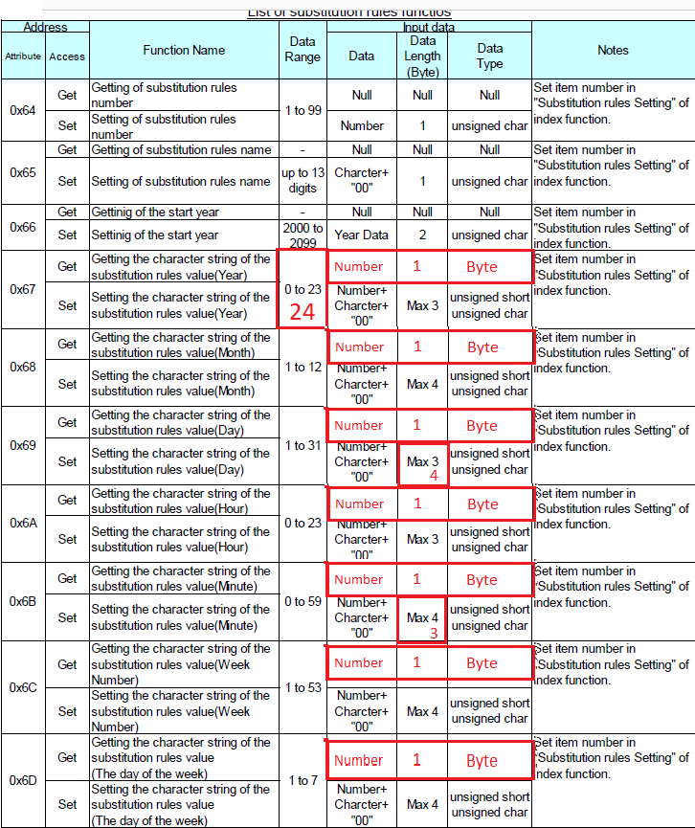

**Implementation Success**

1. Using Index Functions Index and Substitution Rule works priperly.
2. Setting and retrieving the substitution rule settings works properly
3. Getting the name works (did not work in 2.03). Have not tried to set a different name.

**Implementation Issues**

1. Attempts to get the rule number returns 3 bytes (01 E3 07).
   1. 01 == could be the rule number
   2. E3 07 == is 2019 when interpreted as Little Endian
2. Attempts to get the start year returns 1 byte (E3). Could be the leading byte of 2019.
3. Attempts to change the start year to 2018 does not change the start year in the printer.
4. Set Auto Reflection to 1, set the values, and set Auto Reflection to 0 clears all the substitutions.

**Traffic**

See next page.

|  |  |  |  |  |  |  |  |  |  |
| --- | --- | --- | --- | --- | --- | --- | --- | --- | --- |
| **Status/Path** | **Access** | **Class** | **Attribute** | **#In** | **Data In** | **Raw In** | **#Out** | **Data Out** | **Raw Out** |
| **Set Item and substitution rule** | | | | | | | | | |
| 00 -- O.K. -- 33 7A 01 66 | Get | Index | Item | 2 | 1 | 00 01 |  |  |  |
| 00 -- O.K. -- 33 7A 01 6C | Get | Index | Substitution_Rules_Setting | 1 | 1 | 01 |  |  |  |
| **Read one instance of each attribute** | | | | | | | | | |
| 00 -- O.K. -- 33 6C 01 64 | Get | Substitution_rules | Number | 3 | 123655 | 01 E3 07 |  |  |  |
| 00 -- O.K. -- 33 6C 01 65 | Get | Substitution_rules | Name | 5 | "REP01" | 52 45 50 30 31 | 1 | 1 | 01 |
| 00 -- O.K. -- 33 6C 01 66 | Get | Substitution_rules | Start_Year | 1 | 226 | E2 |  |  |  |
| 00 -- O.K. -- 33 6C 01 67 | Get | Substitution_rules | Year | 2 | "01" | 30 31 | 1 | 1 | 01 |
| 00 -- O.K. -- 33 6C 01 68 | Get | Substitution_rules | Month | 3 | "JAN" | 4A 41 4E | 1 | 1 | 01 |
| 00 -- O.K. -- 33 6C 01 69 | Get | Substitution_rules | Day | 3 | " 01" | 20 30 31 | 1 | 1 | 01 |
| 00 -- O.K. -- 33 6C 01 6A | Get | Substitution_rules | Hour | 2 | "01" | 30 31 | 1 | 1 | 01 |
| 00 -- O.K. -- 33 6C 01 6B | Get | Substitution_rules | Minute | 2 | "01" | 30 31 | 1 | 1 | 01 |
| 00 -- O.K. -- 33 6C 01 6C | Get | Substitution_rules | Week | 3 | " 01" | 20 30 31 | 1 | 1 | 01 |
| 00 -- O.K. -- 33 6C 01 6D | Get | Substitution_rules | Day_Of_Week | 3 | "MON" | 4D 4F 4E | 1 | 1 | 01 |
| **Write the Month Substitutions** | | | | | | | | | |
| 00 -- O.K. -- 32 6C 01 68 | Set | Substitution_rules | Month |  |  |  | 5 | JAN | 01 4A 41 4E 00 |
| 00 -- O.K. -- 32 6C 01 68 | Set | Substitution_rules | Month |  |  |  | 5 | FEB | 02 46 45 42 00 |
| 00 -- O.K. -- 32 6C 01 68 | Set | Substitution_rules | Month |  |  |  | 5 | MAR | 03 4D 41 52 00 |
| 00 -- O.K. -- 32 6C 01 68 | Set | Substitution_rules | Month |  |  |  | 5 | APR | 04 41 50 52 00 |
| 00 -- O.K. -- 32 6C 01 68 | Set | Substitution_rules | Month |  |  |  | 5 | MAY | 05 4D 41 59 00 |
| 00 -- O.K. -- 32 6C 01 68 | Set | Substitution_rules | Month |  |  |  | 5 | JUN | 06 4A 55 4E 00 |
| 00 -- O.K. -- 32 6C 01 68 | Set | Substitution_rules | Month |  |  |  | 5 | JUL | 07 4A 55 4C 00 |
| 00 -- O.K. -- 32 6C 01 68 | Set | Substitution_rules | Month |  |  |  | 5 | AUG | 08 41 55 47 00 |
| 00 -- O.K. -- 32 6C 01 68 | Set | Substitution_rules | Month |  |  |  | 5 | SEP | 09 53 45 50 00 |
| 00 -- O.K. -- 32 6C 01 68 | Set | Substitution_rules | Month |  |  |  | 5 | OCT | 0A 4F 43 54 00 |
| 00 -- O.K. -- 32 6C 01 68 | Set | Substitution_rules | Month |  |  |  | 5 | NOV | 0B 4E 4F 56 00 |
| 00 -- O.K. -- 32 6C 01 68 | Set | Substitution_rules | Month |  |  |  | 5 | DEC | 0C 44 45 43 00 |

|  |  |  |  |  |  |  |  |  |  |
| --- | --- | --- | --- | --- | --- | --- | --- | --- | --- |
| **Read the month Substitutions** | | | | | | | | | |
| 00 -- O.K. -- 33 6C 01 68 | Get | Substitution_rules | Month | 3 | "JAN" | 4A 41 4E | 1 | 1 | 01 |
| 00 -- O.K. -- 33 6C 01 68 | Get | Substitution_rules | Month | 3 | "FEB" | 46 45 42 | 1 | 2 | 02 |
| 00 -- O.K. -- 33 6C 01 68 | Get | Substitution_rules | Month | 3 | "MAR" | 4D 41 52 | 1 | 3 | 03 |
| 00 -- O.K. -- 33 6C 01 68 | Get | Substitution_rules | Month | 3 | "APR" | 41 50 52 | 1 | 4 | 04 |
| 00 -- O.K. -- 33 6C 01 68 | Get | Substitution_rules | Month | 3 | "MAY" | 4D 41 59 | 1 | 5 | 05 |
| 00 -- O.K. -- 33 6C 01 68 | Get | Substitution_rules | Month | 3 | "JUN" | 4A 55 4E | 1 | 6 | 06 |
| 00 -- O.K. -- 33 6C 01 68 | Get | Substitution_rules | Month | 3 | "JUL" | 4A 55 4C | 1 | 7 | 07 |
| 00 -- O.K. -- 33 6C 01 68 | Get | Substitution_rules | Month | 3 | "AUG" | 41 55 47 | 1 | 8 | 08 |
| 00 -- O.K. -- 33 6C 01 68 | Get | Substitution_rules | Month | 3 | "SEP" | 53 45 50 | 1 | 9 | 09 |
| 00 -- O.K. -- 33 6C 01 68 | Get | Substitution_rules | Month | 3 | "OCT" | 4F 43 54 | 1 | 10 | 0A |
| 00 -- O.K. -- 33 6C 01 68 | Get | Substitution_rules | Month | 3 | "NOV" | 4E 4F 56 | 1 | 11 | 0B |
| 00 -- O.K. -- 33 6C 01 68 | Get | Substitution_rules | Month | 3 | "DEC" | 44 45 43 | 1 | 12 | 0C |
| **Set auto reflection** | | | | | | | | | |
| 00 -- O.K. -- 32 7A 01 65 | Set | Index | Automatic_reflection |  |  |  | 1 | 1 | 01 |
| 00 -- O.K. -- 33 7A 01 65 | Get | Index | Automatic_reflection | 1 | 1 | 01 |  |  |  |
| **Write the Month Substitutions** | | | | | | | | | |
| 00 -- O.K. -- 32 6C 01 68 | Set | Substitution_rules | Month |  |  |  | 5 | JAN | 01 4A 41 4E 00 |
| 00 -- O.K. -- 32 6C 01 68 | Set | Substitution_rules | Month |  |  |  | 5 | FEB | 02 46 45 42 00 |
| 00 -- O.K. -- 32 6C 01 68 | Set | Substitution_rules | Month |  |  |  | 5 | MAR | 03 4D 41 52 00 |
| 00 -- O.K. -- 32 6C 01 68 | Set | Substitution_rules | Month |  |  |  | 5 | APR | 04 41 50 52 00 |
| 00 -- O.K. -- 32 6C 01 68 | Set | Substitution_rules | Month |  |  |  | 5 | MAY | 05 4D 41 59 00 |
| 00 -- O.K. -- 32 6C 01 68 | Set | Substitution_rules | Month |  |  |  | 5 | JUN | 06 4A 55 4E 00 |
| 00 -- O.K. -- 32 6C 01 68 | Set | Substitution_rules | Month |  |  |  | 5 | JUL | 07 4A 55 4C 00 |
| 00 -- O.K. -- 32 6C 01 68 | Set | Substitution_rules | Month |  |  |  | 5 | AUG | 08 41 55 47 00 |
| 00 -- O.K. -- 32 6C 01 68 | Set | Substitution_rules | Month |  |  |  | 5 | SEP | 09 53 45 50 00 |
| 00 -- O.K. -- 32 6C 01 68 | Set | Substitution_rules | Month |  |  |  | 5 | OCT | 0A 4F 43 54 00 |
| 00 -- O.K. -- 32 6C 01 68 | Set | Substitution_rules | Month |  |  |  | 5 | NOV | 0B 4E 4F 56 00 |
| 00 -- O.K. -- 32 6C 01 68 | Set | Substitution_rules | Month |  |  |  | 5 | DEC | 0C 44 45 43 00 |

|  |  |  |  |  |  |  |  |  |  |
| --- | --- | --- | --- | --- | --- | --- | --- | --- | --- |
| **Clear Auto Reflection** | | | | | | | | | |
| 00 -- O.K. -- 32 7A 01 65 | Set | Index | Automatic_reflection |  |  |  | 1 | 0 | 00 |
| 00 -- O.K. -- 33 7A 01 65 | Get | Index | Automatic_reflection | 1 | 0 | 00 |  |  |  |
| **Read the month Substitutions** | | | | | | | | | |
| 00 -- O.K. -- 33 6C 01 68 | Get | Substitution_rules | Month |  |  |  | 1 | 1 | 01 |
| 00 -- O.K. -- 33 6C 01 68 | Get | Substitution_rules | Month |  |  |  | 1 | 2 | 02 |
| 00 -- O.K. -- 33 6C 01 68 | Get | Substitution_rules | Month |  |  |  | 1 | 3 | 03 |
| 00 -- O.K. -- 33 6C 01 68 | Get | Substitution_rules | Month |  |  |  | 1 | 4 | 04 |
| 00 -- O.K. -- 33 6C 01 68 | Get | Substitution_rules | Month |  |  |  | 1 | 5 | 05 |
| 00 -- O.K. -- 33 6C 01 68 | Get | Substitution_rules | Month |  |  |  | 1 | 6 | 06 |
| 00 -- O.K. -- 33 6C 01 68 | Get | Substitution_rules | Month |  |  |  | 1 | 7 | 07 |
| 00 -- O.K. -- 33 6C 01 68 | Get | Substitution_rules | Month |  |  |  | 1 | 8 | 08 |
| 00 -- O.K. -- 33 6C 01 68 | Get | Substitution_rules | Month |  |  |  | 1 | 9 | 09 |
| 00 -- O.K. -- 33 6C 01 68 | Get | Substitution_rules | Month |  |  |  | 1 | 10 | 0A |
| 00 -- O.K. -- 33 6C 01 68 | Get | Substitution_rules | Month |  |  |  | 1 | 11 | 0B |
| 00 -- O.K. -- 33 6C 01 68 | Get | Substitution_rules | Month |  |  |  | 1 | 12 | 0C |